**Templating Engines**

Write note here..

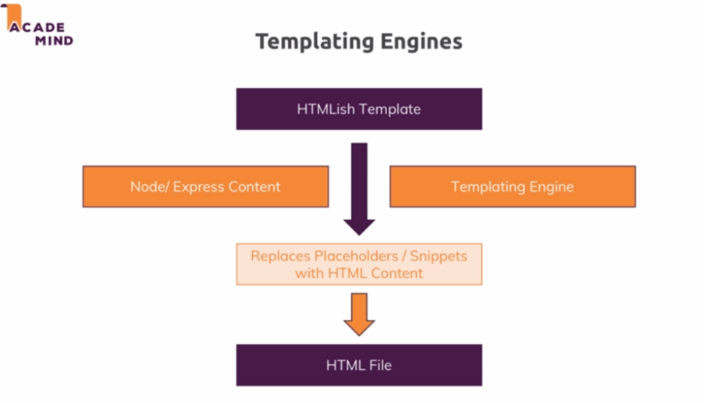

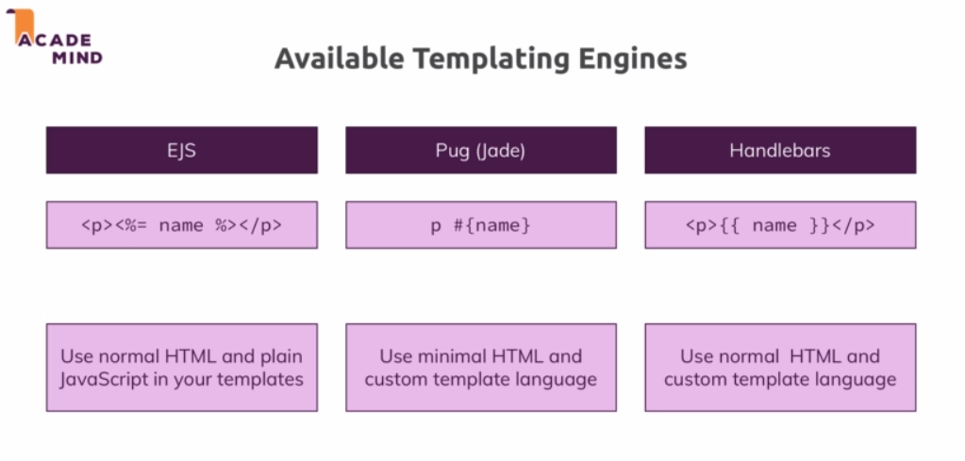

**Installation:**

npm install --save ejs

npm install --save pug

npm install --save express-handlebars

**Implementing:**

app.set(‘view engine’, ‘pug’)

app.set(‘views’, ‘views’)